CLAYTON COUNTY WATER AUTHORITY
Regular Board Meeting
1600 Battle Creek Road
Morrow, GA 30260

Present at the meeting were: Chairman John Chafin, Vice Chairman Marie Barber, Secretary/Treasurer Rodney Givens, Board Member John Westervelt, Board Member Dr. Cephus Jackson, Board Member Robin Malone, Board Member Vivian Baldwin, General Manager Bernard Franks, Assistant General Manager Teresa Worley, Assistant General Manager Keisha Thorpe, Legal Counsel Serena L. Nowell, Executive Coordinator Amanda La Pierre, other CCWA staff and visitors.

Invocation
John Chafin introduced Sr. Engineering Technician Michael Shinn to perform the invocation.

Adoption of Agenda
UPON MOTION by Dr. Cephus Jackson and second by Rodney Givens, to adopt the agenda as presented, it was unanimously

RESOLVED to adopt the agenda as presented.

Approval of Minutes
Chairman John Chafin called for any omissions or additions to the Minutes of the Regular Board Meeting held on February 7, 2019.

UPON MOTION by Dr. Cephus Jackson and second by Vivian Baldwin, it was unanimously

RESOLVED to approve Amended Minutes of the Regular Board Meeting held on February 7, 2019 to include a correction to the spelling of Marie Barber’s name

Financial and Statistical Reports
Finance Director Allison Halron reviewed the financial information distributed to the Board for the period ending January 31, 2019. Information only, no action taken.

Recognition

GFOA Distinguished Budget Presentation Award: Public Information Officer Suzanne Brown recognized the Finance Department for receiving the Government Finance Officers Association (GFOA) Distinguished Budget Presentation Award. Information only, no action taken.

New Business

Household Hazardous Waste Day Bid Recommendation: Stormwater Manager Kevin Osbey presented a recommendation on the Household Hazardous Waste Day Bid.

Clayton County Water Authority received bids from the companies shown below for Household Hazardous Waste Amnesty Day materials collections for the Stormwater Utility. The purpose of this event is to provide a safe and effective means for the residents of Clayton County to properly dispose of household hazardous items. These items include, but are not limited to, paints, cleaners, pesticides, motor oils, antifreeze, gas & fuels, fertilizers, and cooking oil.
This is a one-day event to be held on Saturday, April 27, 2019. This will be the 12th year that CCWA manages the event and the 11th year taking place at the W.B. Casey Water Reclamation Facility.

Contractor | Total Bid Summary
CARE Environmental Corporation  Valdosta, GA | $31,723.80
MXI Environmental Services  Abingdon, VA | $51,600.00
Perma-Fix Environmental Services  Gainesville, FL | $57,420.00
ECOFLO, Inc.  Greensboro, NC | $59,255.00
Tradebe Environmental Services  Merrillville, IN | $133,950.00
Clean Earth  Glencoe, AL | $141,530.00

Clayton County Water Authority Bid Tabulation
Household Hazardous Waste (Amnesty) Day
Tuesday, February 5, 2019
 |  |  |  | CARE ENVIRONMENTAL |  | MXI ENVIRONMENTAL SERVICES |  | PERMA-FIX  ENVIRONMENTAL SERVICES |  | ECOFLO |  | TRADEBE  ENVIRONMENTAL SERVICES |  | CLEAN EARTH
No. | Detail | Quantity | Unit of  Measure | Unit Cost | Extension | Unit Cost | Extension | Unit Cost | Extension | Unit Cost | Extension | Unit Cost | Extension | Unit Cost | Extension
1 | Base - Oil based paint, stains, thinners and paint strippers, solvents and varnishes, wood preservatives | 27,000 | LB | 0.199 | 5,373.00 | 0.35 | 9,450.00 | 0.05 | 1,350.00 | 0.28 | 7,560.00 | 0.91 | 24,570.00 | 0.35 | 9,450.00
2 | Aerosol/spray paint | 2,500 | LB | 0.470 | 1,175.00 | 0.75 | 1,875.00 | 1.60 | 4,000.00 | 1.00 | 2,500.00 | 1.01 | 2,525.00 | 0.55 | 1,375.00
3 | Latex and water-based paints | 27,000 | LB | 0.199 | 5,373.00 | 0.25 | 6,750.00 | 0.35 | 9,450.00 | 0.16 | 4,320.00 | 0.38 | 10,260.00 | 0.25 | 6,750.00
4 | Mercury - Mercury salts and elemental mercury thermometers, thermostats, and other mercury containing items | 500 | LB | 0.000 | 0.00 | 1.00 | 500.00 | 1.00 | 500.00 | 3.75 | 1,875.00 | 7.97 | 3,985.00 | 6.00 | 3,000.00
5 | Fluorescent bulbs and ballasts | 2,500 | LB | 0.300 | 750.00 | 0.50 | 1,250.00 | 0.60 | 1,500.00 | 0.77 | 1,925.00 | 1.25 | 3,125.00 | 0.75 | 1,875.00
6 | Lawn care products - Poisons, insecticides, weed killer and pesticides, Aerosol/spray pesticides | 9,000 | LB | 0.699 | 6,291.00 | 1.25 | 11,250.00 | 1.80 | 16,200.00 | 1.20 | 10,800.00 | 1.21 | 10,890.00 | 0.90 | 8,100.00
7 | Automotive Products - Motor Oil, Engine Degreaser, Brake Fluid, Transmission Fluid, Antifreeze, etc. | 10,000 | LB | 0.199 | 1,990.00 | 0.25 | 2,500.00 | 0.25 | 2,500.00 | 0.25 | 2,500.00 | 0.25 | 2,500.00 | 0.10 | 1,000.00
8 | Cleaners, Corrosives, Spot Removers, Acids and Bases | 3,000 | LB | 0.470 | 1,410.00 | 0.75 | 2,250.00 | 0.60 | 1,800.00 | 1.20 | 3,600.00 | 1.21 | 3,630.00 | 0.85 | 2,550.00
9 | Oxidizers | 9,500 | LB | 0.470 | 4,465.00 | 0.25 | 2,375.00 | 0.25 | 2,375.00 | 0.99 | 9,405.00 | 2.21 | 20,995.00 | 2.00 | 19,000.00
10 | Flammables - Lighter Fluid and Waste Fuels (As Kerosene,  Gasoline, Diesel, etc.) | 7,000 | LB | 0.199 | 1,393.00 | 0.35 | 2,450.00 | 0.25 | 1,750.00 | 0.25 | 1,750.00 | 1.13 | 7,910.00 | 0.20 | 1,400.00
11 | Batteries - Household and Rechargeable | 1,200 | LB | 0.240 | 288.00 | 0.50 | 600.00 | 0.80 | 960.00 | 1.00 | 1,200.00 | 1.21 | 1,452.00 | 0.75 | 900.00
12 | Auto Batteries | 500 | LB | 0.000 | 0.00 | 0.00 | 0.00 | 0.00 | 0.00 | 0.00 | 0.00 | 41.00 | 20,500.00 | 0.00 | 0.00
13 | Cooking Grease | 500 | LB | 0.470 | 235.00 | 0.25 | 125.00 | 0.25 | 125.00 | 0.25 | 125.00 | 0.41 | 205.00 | 0.10 | 50.00
14 | Propane Cylinders | 1,500 | LB | 0.240 | 360.00 | 1.00 | 1,500.00 | 0.75 | 1,125.00 | 1.00 | 1,500.00 | 2.05 | 3,075.00 | 3.00 | 4,500.00
15 | Fire Extinguishers | 600 | LB | 0.470 | 282.00 | 0.50 | 300.00 | 0.10 | 60.00 | 0.20 | 120.00 | 2.13 | 1,278.00 | 1.00 | 600.00
16 | Chlorinated Solvents | 500 | LB | 0.000 | 0.00 | 0.25 | 125.00 | 0.25 | 125.00 | 0.25 | 125.00 | 0.86 | 430.00 | 0.20 | 100.00
17 | Pharmaceuticals | 1,200 | LB | 0.699 | 838.80 | 0.25 | 300.00 | 0.50 | 600.00 | 0.25 | 300.00 | 2.80 | 3,360.00 | 0.90 | 1,080.00
18 | Mobilization charges, including all, equipment, supplies, transportation, insurance and/or additional charges. (Priced per each) | 1 | EA | 1,500.000 | 1,500.00 | 2,000.00 | 2,000.00 | 3,500.00 | 3,500.00 | 3,650.00 | 3,650.00 | 2,660.00 | 2,660.00 | 3,800.00 | 3,800.00
19 | Labor charges - Provide enough personnel to accommodate a minimum of 200 vehicles per hour (Priced per each) | 20 | EA | 0.000 | 0.00 | 300.00 | 6,000.00 | 475.00 | 9,500.00 | 300.00 | 6,000.00 | 530.00 | 10,600.00 | 3,800.00 | 76,000.00
 | TOTAL BID AMOUNT |  |  | $ 31,723.80 |  |  | $ 51,600.00 | $ 57,420.00 |  | $ 59,255.00 |  | $ 133,950.00 |  | $ 141,530.00

Recommendation:
Upon review of the Bid Submittals, CARE Environmental Corporation was deemed the lowest responsive and responsible bidder, for these services, based on the unit pricing provided on the Bid Tabulation sheet.

UPON MOTION by Dr. Cephus Jackson and second by Vivian Baldwin, it was unanimously

RESOLVED to award the bid to CARE Environmental Corporation based on their unit prices with an option to renew for a second and third year with the same terms and conditions, contingent upon the bidder meeting risk management requirement and executing the contracts as well as the Board authorizing the General Manager to sign the contracts.

Water and Wastewater Treatment Chemicals Bid Recommendation: Water Production Manager Kendra Stanciel presented a recommendation on the Water and Wastewater Treatment Chemicals Bid.

On February 06, 2019, Clayton County Water Authority received bids for its annual Water and Wastewater Treatment Chemicals for CCWA’s Water Production and Water Reclamation Facilities. Clayton County Water Authority received bid packages from 29 vendors with 28 different vendors submitting bids for the 24 chemicals advertised.
We received identical bids for the chemicals Sodium Silica Fluoride and Copper Sulfate. According to our instructions to bidder, in the event of two or more vendors that are identical in price, meets delivery and bid specifications as well as the criteria set forth in the document splitting of the award and awarding to an individual vendor is based on the toss of a coin. A coin toss was performed on February 20, 2019 to determine the vendor that would be awarded the bid for Cooper Sulfate with representative of each vendor attending via phone in the presence of CCWA staff.

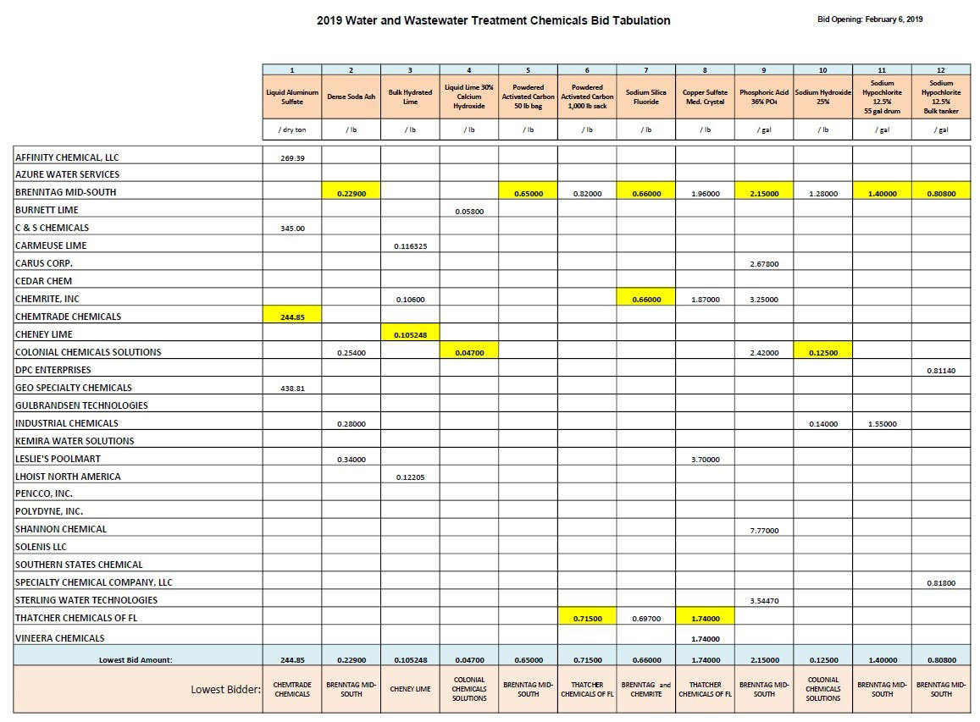
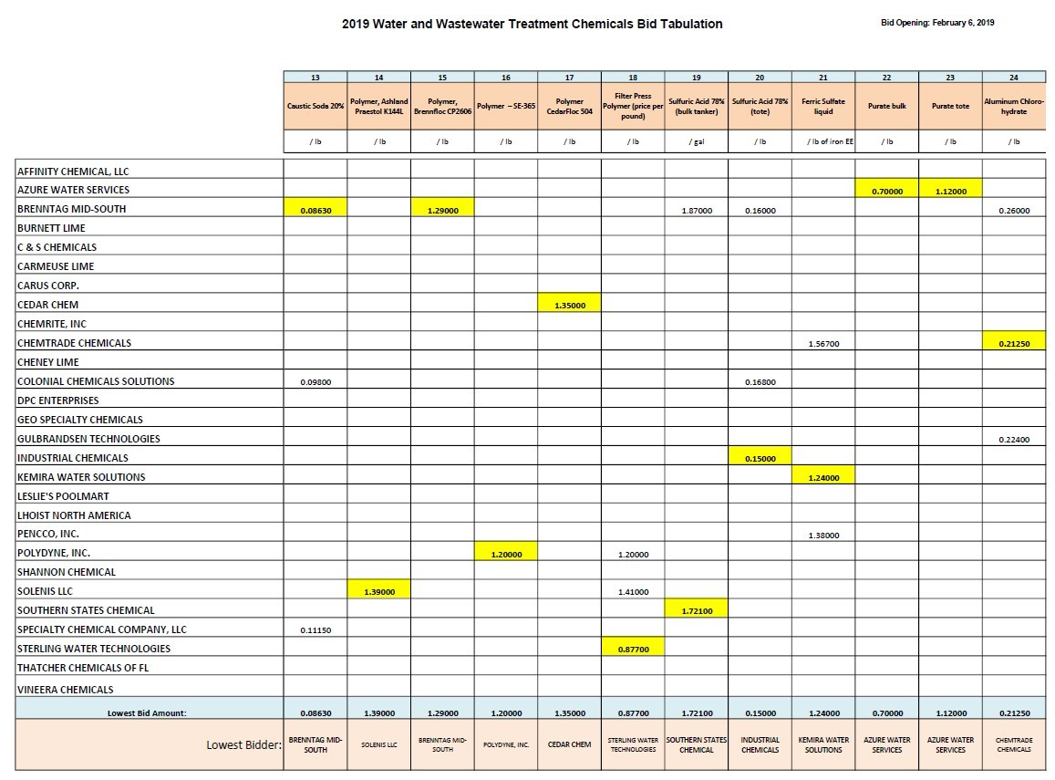

Recommendation:
CCWA staff recommended awarding the Water and Wastewater Treatment Chemicals Bid to the individual companies that have submitted the lowest responsive responsible bid for each chemical; along with splitting the award of sodium silica fluoride between Brenntag and Chemrite for the year and awarding the copper sulfate bid to Thatcher based on the results of the coin toss and its limited usage.

UPON MOTION by Marie Barber and second by Vivian Baldwin, it was unanimously

RESOLVED to award the Water and Wastewater Treatment Chemicals Bid to the individual companies that have submitted the lowest responsive responsible bid for each chemical; along with splitting the award of sodium silica fluoride between Brenntag and Chemrite for the year based on the results of the coin toss and its limited usage and awarding the copper sulfate bid to Thatcher; contingent upon the bidder meeting risk management requirement and executing the contracts as well as the Board authorizing the General Manager to sign the contracts.

Generator Design Service Task Order Recommendation: Water Production Manager Kendra Stanciel presented a recommendation on the Generator Design Service Task Order.

The William J. Hooper is our largest Water Production Plant with a current capacity that delivers up to 20 MGD. This plant currently has a small generator that only has the capabilities to power emergency lighting at the facility and no back up power to sustain critical plant operations in case of an emergency. Due to the critical nature of this plant in CCWA’s distribution system the installation of standby power capable of powering the entire existing plant load is greatly needed.

Cost Summary
Tasks |  | Cost
Task 1 – Design |  | $84,760
Task 2 – Bid Phase Assistance |  | $9,960
 | TOTAL | $94,720

Recommendation:
CCWA staff recommended awarding the Generator Design Service Task Order to Hazen and Sawyer for the W.J. Hooper WPP standby generator in the amount of $94,720.00.
UPON MOTION by Rodney Givens and second by Dr. Cephus Jackson, it was unanimously
RESOLVED to award the Generator Design Service Task Order to Hazen and Sawyer for the W.J. Hooper WPP standby generator for a not to exceed cost of $94,720.00 and to authorize the General Manager to sign the Task Order.
Lobby Security Request: Risk Manager Karen Riser presented a recommendation on the Lobby Security Request.

In August, two upset customers began beating on the protective glass windows at the front counter of the HQ lobby. They cursed at customers and staff. On other occasions, a local homeless man had to be confronted for throwing bottles at or near the customer entrance and on one occasion dumped trash in the customer entrance. Customer Service Representatives have reported possible stalkers, armed customers openly carrying firearms, and at Forest Park the isolation of the location has caused great concern for the safety of staff members.

These and other similar events over the last few months have prompted those of us responsible for the safety and security of our employees to investigate added protections if something were to occur when our Safety & Compliance Officer is unavailable. Additionally, we identified a need for a continuous, visible deterrent throughout our hours of operation.

Recommendation:
CCWA staff recommended the approval of a contract with Romero Consulting, LLC. to staff the CCWA Headquarters and Forest Park locations with sworn, local law enforcement officers in the customer lobby areas at the not to exceed annual cost of $228,000.00.

UPON MOTION by Dr. Cephus Jackson and second by John Westervelt, it was unanimously
RESOLVED to award the contract to Romero Consulting, LLC. for a not to exceed cost of $228,000.00, with an option to renew for a second and third year with the same terms and conditions, contingent upon the bidder meeting risk management requirement and executing the contract as well as the Board authorizing the General Manager to sign the contract.
NTS Aquatic Work Boat Purchase Recommendation: Water Reclamation Manager Chris Hamilton presented a recommendation on the NTS Aquatic Work Boat Purchase.

The Clayton County Water Authority’s constructed wetlands are used for effluent polishing from both the Casey and Shoal Creek Water Reclamation Facilities. Excess pollutants/nutrients not removed in the wastewater treatment processes at the Water Reclamation Facilities are taken up by the vegetation in the treatment wetlands. The vegetation in the wetland can grow rapidly during the warmer months and can cause short-circuiting of the flow through the wetland cells. To maintain optimum treatment efficiencies and avoid short-circuiting, a uniform distribution of flow must be maintained in the wetland cells. As a rule of thumb there is normally little vegetation management required however if areas become overgrown, they should be thinned out to maintain a uniform flow pattern through the wetland cells.

This aquatic workboat is a one of a kind piece of equipment made specifically for removing floating vegetation from bodies of water. There are similar types of equipment on the market but not comparable to this workboat and its specifications. Other aquatic harvesters are larger than the Weedoo workboat which makes them difficult to transport and to launch in to the individual wetland cells. This boat is better suited for small wetland ponds (like the ones on the Huie site) than any other equipment that has been researched and demonstrated. The Water Reclamation Staff have searched for other vendors who could provide an aquatic harvester similar in size and capabilities but had no success in doing so.

Vendor | Purchase Price | Comments | Make / Model
Weedoo Greenboat Inc.  West Palm Beach Florida | $74,126.00 | Sole Source Purchase | Weedoo 334 workboat

Recommendation:
CCWA staff recommended the approval of a sole source purchase for the Weedoo 334 Workboat aquatic workboat from Weedoo Greenboat Inc. in the amount of $74,126.

UPON MOTION by John Westervelt and second by Marie Barber it was unanimously
RESOLVED to award the sole source purchase of a Weedoo 334 Workboat to Weedoo Greenboat, Inc. for the total cost of $74,126.00.
Executive Session
UPON MOTION by Dr. Cephus Jackson and second by John Westervelt, it was unanimously
RESOLVED to enter an Executive Session in order to discuss land legal matters.

UPON MOTION by Marie Barber and second by Robin Malone, it was unanimously
RESOLVED to leave the Executive Session and return to open session.

Updates from the Board Members and General Manager
UPON MOTION by Dr. Cephus Jackson and second by John Westervelt it was unanimously
RESOLVED to approve the Executive Session minutes as presented.

Karen Riser presented an update on the SLBE (Small Local Business Enterprise) program.

UPON MOTION by Rodney Givens and second by Dr. Cephus Jackson it was unanimously
RESOLVED to approve Resolution #2019-02 and amend the CCWA Law and Policy Manual as presented. (Absent: Marie Barber).

Kevin Osbey provided an update on an emergency stormwater repair.

Ed Durham and Michelle Jordan provided an update on employee health insurance. The Board agreed to a 5% increase in insurance premiums for Fiscal Year 2019 – 2020.

Ed Durham provided an update on the Compensation Study.

Teresa Worley presented a recommendation on updating policies concerning sub-metering and fire lines.

UPON MOTION by John Westervelt and second by Dr. Cephus Jackson it was unanimously
RESOLVED to approve Resolution #2019-01 and amend the CCWA Law and Policy Manual as presented. (Absent: Marie Barber).

Teresa Worley provided an update on the Forest Park Payment Center.

UPON MOTION by Dr. Cephus Jackson and second by Rodney Givens it was unanimously
RESOLVED to approve a one-year extension with our current janitorial vendor. (Absent: Marie Barber).

Bernard Franks presented a preview of the Budget Retreat agenda.

Bernard Franks provided an update on the Arts Clayton Arte Gras event.

Bernard Franks provided an update on the State of the County event.

Bernard Franks provided an update on the Clean 13 event.

Bernard Franks provided an update on the Women in Business Luncheon.

Adjourn

UPON MOTION by Dr. Cephus Jackson and second by Robin Malone it was unanimously

RESOLVED to adjourn the Board Meeting at 4:29 p.m., there being no further business to come before the Board of Directors.

_____________________________ _________________________________

John Chafin, Chairman Rodney Givens, Secretary/Treasurer

STATE OF GEORGIA
COUNTY OF CLAYTON

RESOLUTION NO. 2019-01
WHEREAS, Georgia Laws 1955, page 3334, created the Board of the Clayton County Water Authority;
WHEREAS, the Clayton County Water Authority Board of Directors ("Board") has adopted a Clayton County Water Authority Law and Policy Manual; and
WHEREAS, the Board wishes to update the Clayton County Water Authority Law and Policy Manual.
NOW THEREFORE, BE IT AND IT IS HEREBY RESOLVED THAT:
Section 9 and Section 21. UNMETERED FIRE LINES & MULTIPLE HOUSING WATER AND WASTEWATER CONNECTIONS. That Chapter 8 is
hereby amended of the Clayton County Water Authority Law and Policy Manual to read as follows:
1 6-1
SECTION 21SUB-METERING
04-1 multi-unit residential retail and fight industrial buildings are required to me asure the quantity of water used by each unit: Sub-meters must be instaned during construction. peejeets theFe-aiædesiFihg-ser:vi€e
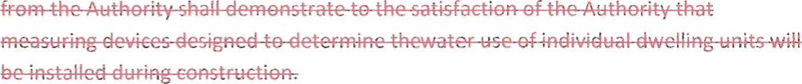
(Reference minutes of January 6, 1983 Page 172)
SECTION 9 UNMETERED FIRE LINES
Fire connections are not to be used for any use other than fighting fires (and for testing the ability of the equipment to fight fires). In circumstances where, in the opinion of the Authority, water may be being used through an unmetered fire connection, the Authority will notify the customer of the situation and take whatever means necessary to determine if water is being used. If it is determined that water is being used through the unmetered fire connection, the Authority may cause the customer to install, at their expense, a meter on this line. For all new construction, all fire lines shall h ave a proper meter and double check valve installed prior to the initiation of initial service to the site at the owner's expense . For ati renovation proiect that add tg or modify existing unmetered fire lines, the Authority shall reguire the owner to in stall at the owner's expense, a meter and double check valve on the fire\ine.
(Reference minutes of September 2000 Pages 2109 — 2110)Formi
Section 2. General Authority. From and after the adoption of this Resolution, the Board and the proper members, agents and employees of the Board are hereby authorized, empowered and directed to do all such acts and things and to execute all such documents as may be necessary to carry out and comply with the intent of this Resolution.
Section 3. Actions Ratified, Approved, and Confirmed. All acts and doings of the members of the Board which are in conformity with the purposes and intents of this Resolution shall be, and the same hereby are, in all respects ratified, approved, and confirmed.
Section 4. Recordation. This Resolution shall be recorded in the minutes of the Board.
Section 5. Severability of Invalid Provisions. The sections, paragraphs, sentences, clauses, and phrases of this Resolution are severable, and if any phrase, sentence, paragraph, or section of this Resolution shall be declared illegal by the valid judgment or decree of any court of competent jurisdiction, such an illegality shall not affect any of the remaining phrases, clauses, sentences, paragraphs, and sections of this Resolution.
Section 6. Repealing Clause. All resolutions or parts thereof of the Board in conflict with the provisions herein contained are, to the extent of such conflict, hereby superseded and repealed.
Section 7. Effective Date. This Resolution shall become effective upon its adoption.
SO RESOLVED this 7th day of March 2019.
Clayton County Water Authority:
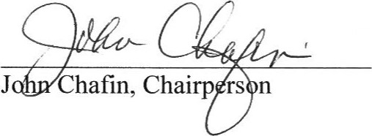
Attest:
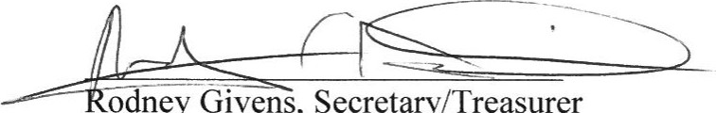
odney
Givens,
Secretary/
Treasurer
APPROVED AS TO FORM:
Steven M. Fincher, Attorney for
Clayton County Water Authority
STATE OF GEORGIA
COUNTY OF CLAYTON
RESOLUTION NO. 2019-02
WHEREAS, Georgia Laws 1955, page 3334, created the Board of the Clayton County Water Authority;
WHEREAS, the Clayton County Water Authority Board of Directors ("Board") has adopted a Clayton County Water Authority Law and Policy Manual; and
WHEREAS, the Board wishes to update the Clayton County Water Authority Law and Policy Manual.
NOW THEREFORE, BE IT AND IT IS HEREBY RESOLVED THAT:
Section 3. PURCHASING POLICIES That Chapter 12 is hereby amended of the
Clayton County Water Authority Law and Policy Manual to read as follows:
- Substitution/removal of any SLBE subcontract, vendor or supplier previously selected by the prime contractor cannot be made without prior approval of the Contracts, Compliance and Risk Management Section. The substitution/removal of any pre-approved SLBE subcontractor, vendor or supplier requires the completion and approval of the Request for Subcontractor Removal/Substitution form. Additional information can be found in the CCWA Small Local Business Enterprise Guidelines.
- Penalties for non-compliance with the SLBE program requirements may be assessed by the General Manager or their designee. Additional information can be found in the CCWA Small Local Business Enterprise Guidelines.
Section 2. General Authority. From and after the adoption of this Resolution, the Board and the proper members, agents and employees of the Board are hereby authorized, empowered and directed to do all such acts and things and to execute all such documents as may be necessary to carry out and comply with the intent of this Resolution.
1 6-1
Section 3. Actions Ratified, Approved, and Confirmed. All acts and doings of the members of the Board which are in conformity with the purposes and intents of this Resolution shall be, and the same hereby are, in all respects ratified, approved, and confirmed.
Section 4. Recordation. This Resolution shall be recorded in the minutes of the Board.
Section 5. Severability of Invalid Provisions. The sections, paragraphs, sentences, clauses, and phrases of this Resolution are severable, and if any phrase, sentence, paragraph, or section of this Resolution shall be declared illegal by the valid judgment or decree of any court of competent jurisdiction, such an illegality shall not affect any of the remaining phrases, clauses, sentences, paragraphs, and sections of this Resolution.
Section 6. Repealing Clause. All resolutions or parts thereof of the Board in conflict with the provisions herein contained are, to the extent of such conflict, hereby superseded and repealed.
Section 7. Effective Date. This Resolution shall become effective upon its adoption.
SO RESOLVED this 7th day of March 2019.
Clayton County Water Authority:
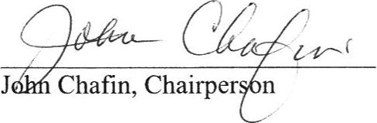
Attest:
| 6-2
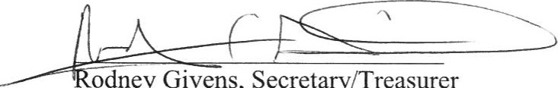
odney
Givens,
Secretary/Treasurer
APPROVED AS TO FORM:
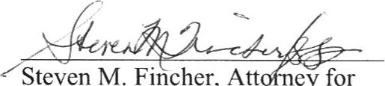
Steven M. Fincher, Att
ey
for
Clayton County Water Authority

